22. PSU assembly

NOTE: If you opt to use a 12V 30A PSU, skip this chapter and just mount it on the right stay
NOTE: Mains voltage is not dangerous, as long you use some common sense and have some respect for it.
NOTE: The instructions given here are based on a Corsair CX 600 PSU, but they are all similar. Should you decide to pick something different here are what to go for:
- Must NOT be modular, ie you want one where all the wires are attached to the inside
- Must be singe rail 12V

Vitamins
1 THS15 Aluminium clad resistor 10R 10W  1 THS15 Aluminium clad resistor 4R7 10W  1 PSU  4 M4 cap screw x 16mm  1 IEC mains lead  4 Nyloc nut M2.5  4 Nyloc nut M4  4 M2.5 pan screw x 12mm  2 6-32 pan screw x 9.5mm | 1 Heatshrink sleeving ID 10mm x 15mm  3 Heatshrink sleeving ID 2.4mm x 15mm  5 Heatshrink sleeving ID 3.2mm x 15mm  2 Heatshrink sleeving ID 6.4mm x 15mm  4 Washer M2.5 x 5.9mm x 0.5mm  6 Washer M4 x 9mm x 0.8mm  2 Star washer M4 x 0.8mm  2 Zip-tie 100mm min length  1 green led  1 red led  150 ohm resistor  200 ohm resistor

Printed parts
1 atx_long_bracket.stl  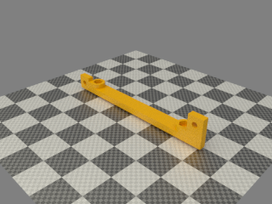 | 1 atx_short_bracket.stl  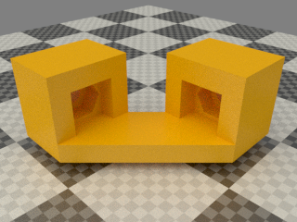

Wiring
- Start by opening the PSU, it can be very fiddley work as some parts of the lid kind of interlocks with the case. Also the fan can catch on the case so as straight up as possible helps
- Be very carefull when you get the lid loose as the fan needs to be disconnected
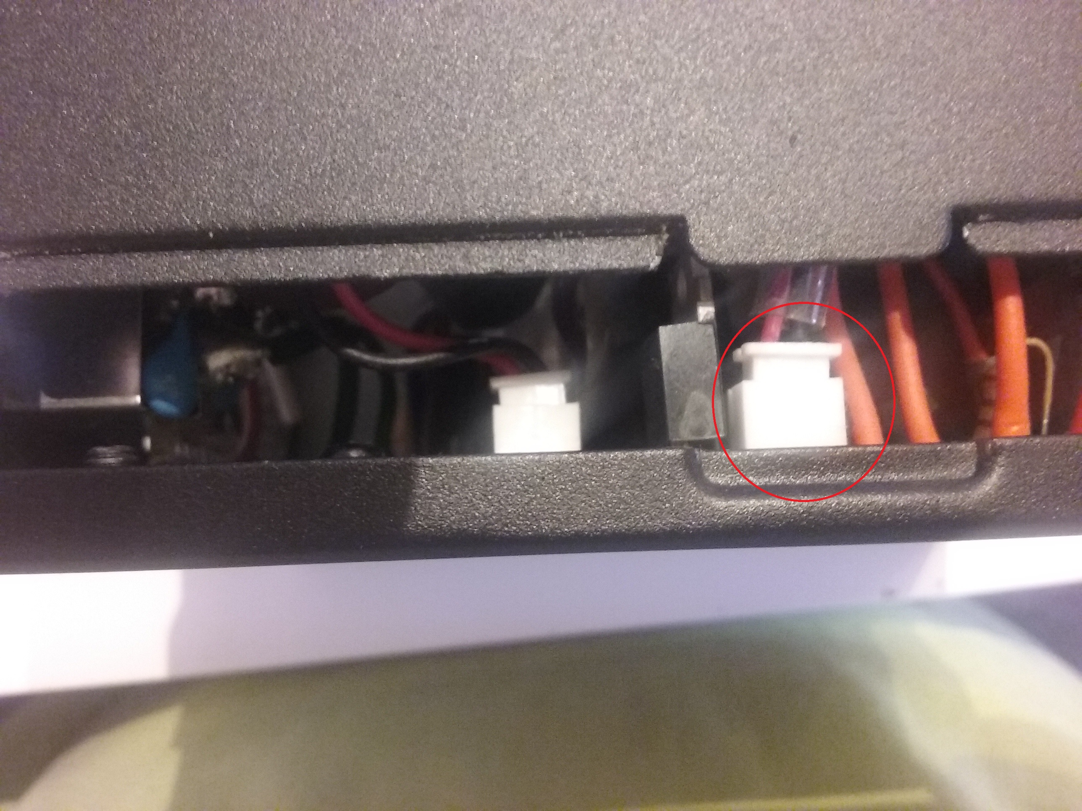
- Unscrew the board in the psu at the 4 corners
- Praise the round plastic part that holds the wires in place
- Carefully manuver the board on its side by pullin up at the back and rotate it 90 degrees. The mains voltage part is the lower part in the next picture. We will work far away from that so no worries.
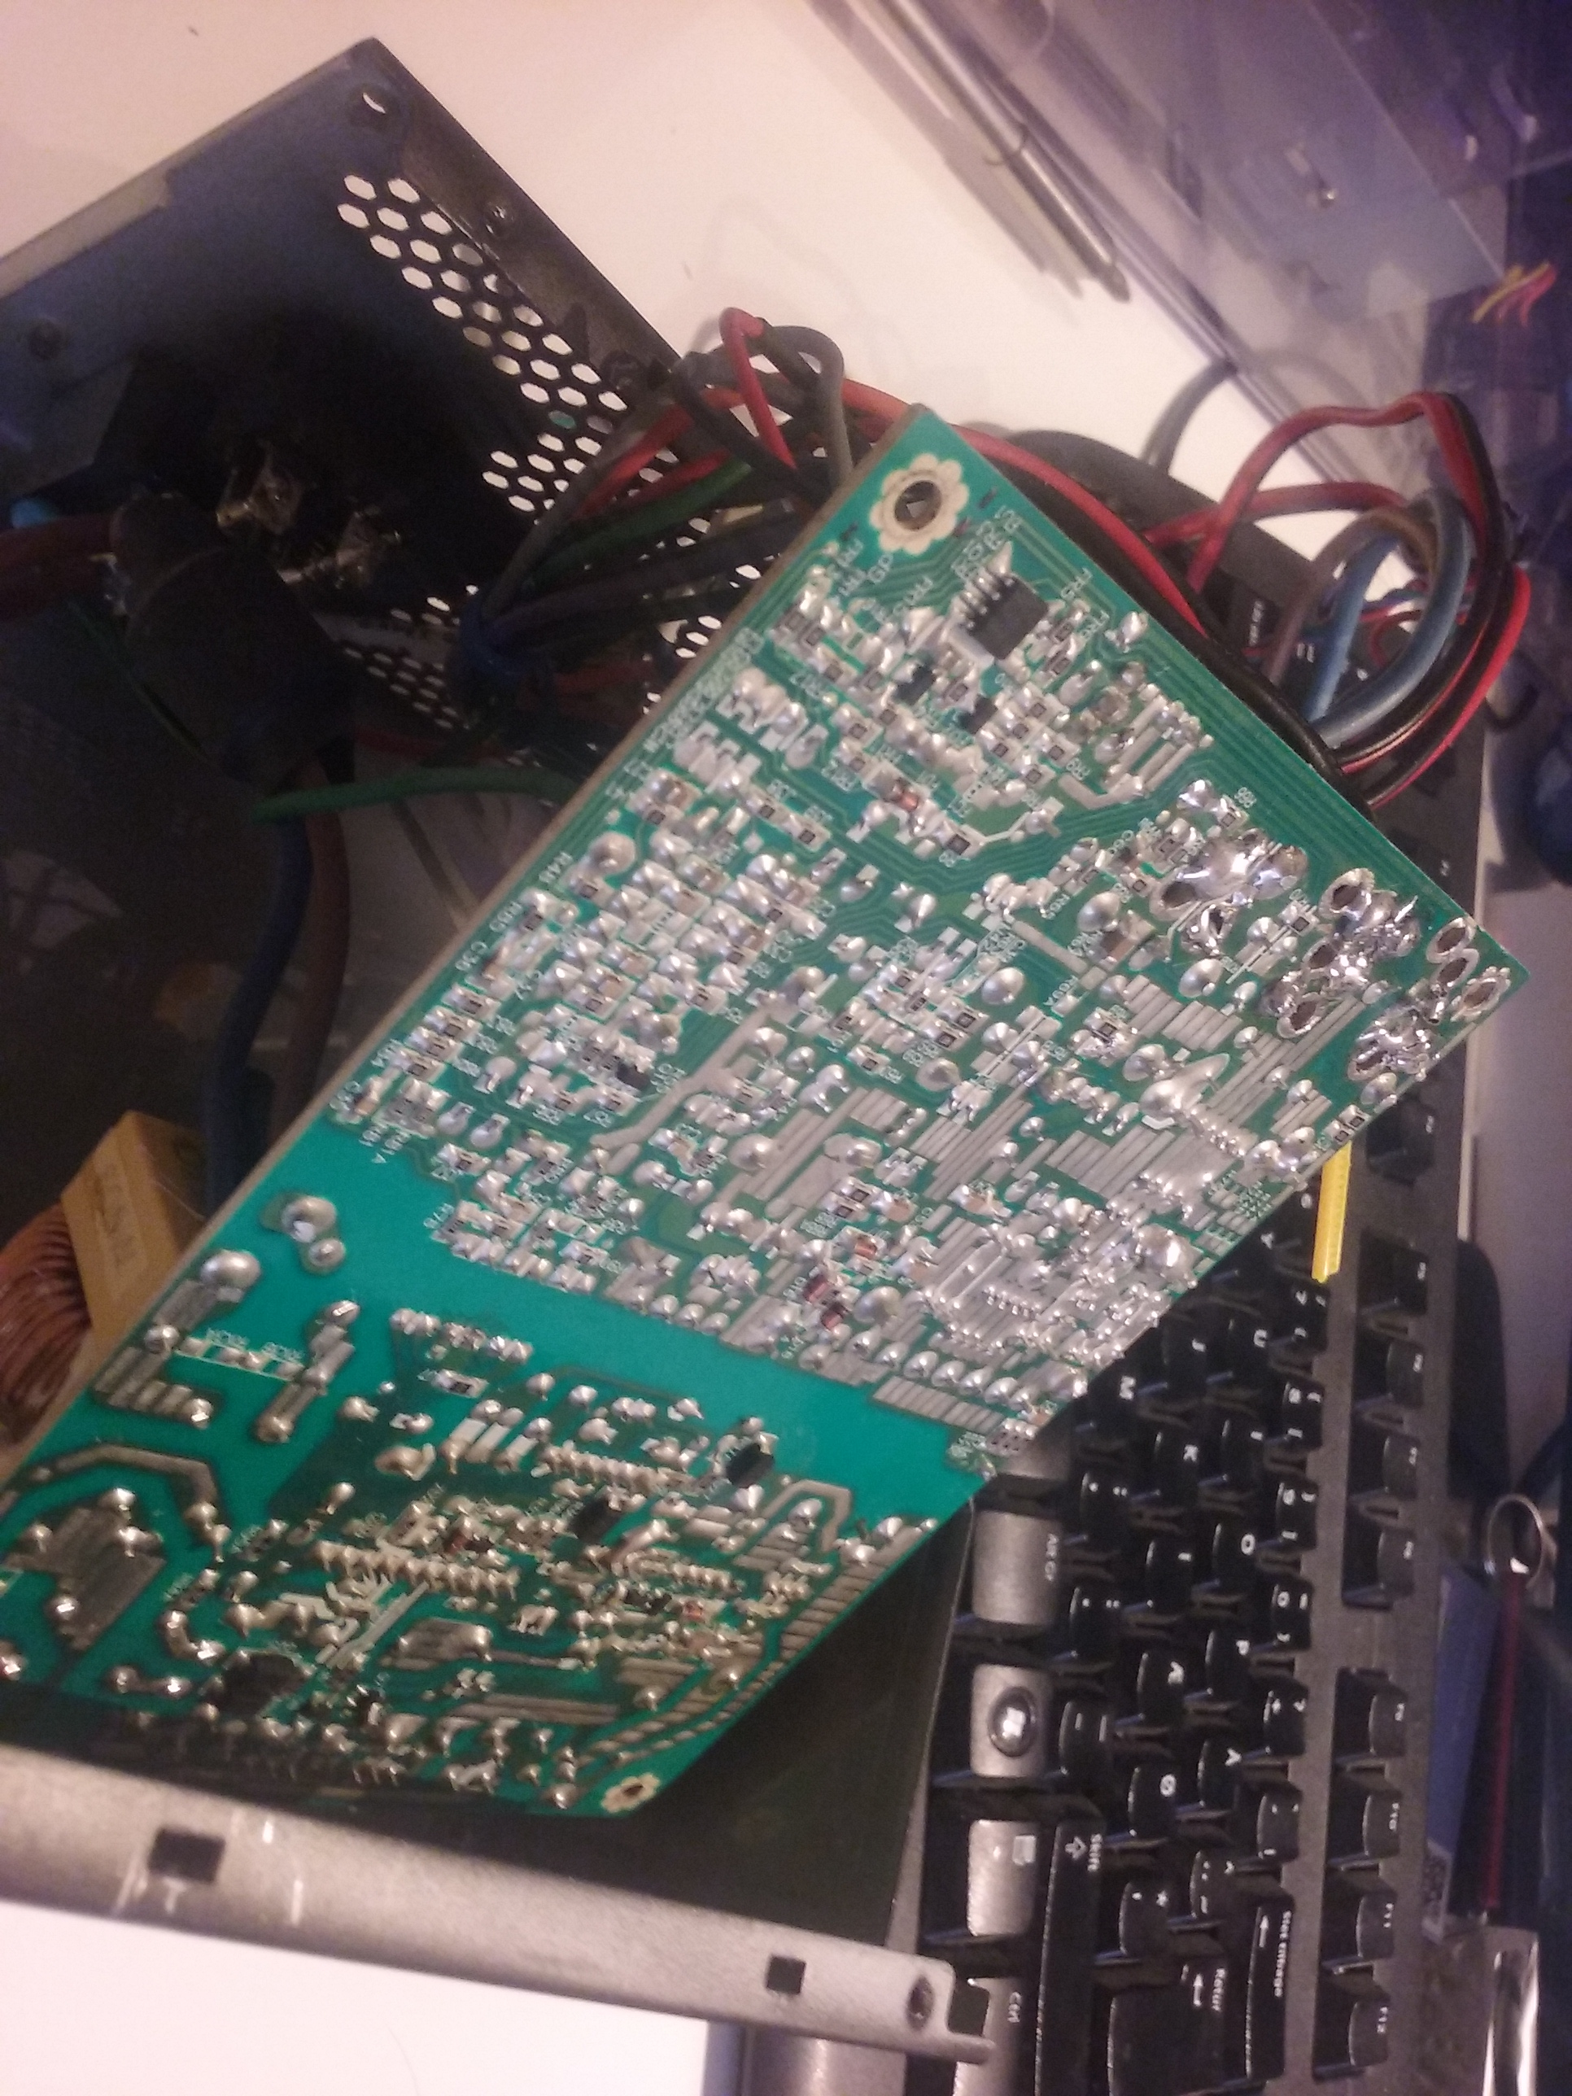
- We will remove most of the wires but we need to keep a few
- 3.3V Sense (Orange)
- 3.3V (Orange)
- 5V Standby (Purple)
- 5V (Red)
- Power Good (Gray)
- PSU ON (Green)

- Follow the 3.3V sense from the board and cut it off as far away you can
- Do the same for power good and 5V standby and one 3.3V also the PSU ON. Bend all these now loose wires aside
- The remaing wires will be a challange to remove. They are crimped in a bundle and soldered on to the board and this gives a big mass to heat up to get them out without ripping up tracks etc. The best way is to cut the wires as close to the crimp as possible but skip a few wires in each bundle so you can grip them with nose pliers
- Start with the GND’s as those will be the hardest but most easy to get to.
- With a soldering iron with a good bloop of solder on start to heat up one of the crimps while you grip the wires left with pliers. It will take some time but at some point you will see the crimp move. Now pull gently on the wires while you carefull wiggle on the wire. The crimp should slide out. Go on to the next and do the same. As you remove them it will go faster as there is less mass to heat up.
- Once they are all out, clean up the holes so there are no solder blobs and the holes are empty. You might want to use solder wick
- Now cut the 3.3V sense wire down to about 5 cm lenght, then strip of about 3mm and tin it then solder it to one of the smaller 3.3 V holes
- Cut a orange wire to 30cm lenght (you can take it from the wires just removed. Strip 5mm insulation and tin and solder it in the 3.3V hole. Get it as flush with the PCB as possible. It must NOT stick out further than what is there allready.
- Do the same with a red wire for the 5V hole.
- Take 3 black wires and solder them in one of the GND holes.
- Gently put back the board but do not screw it in place. Route the wires along the edge of the case, over the power plug following the top use small zip ties to bundle them together
- Solder one of the black wires and the red wire to the 10 ohm resistor. Trim wires to lenght as needed so resistor can be mounted on the grill section
- Solder the 4,7 ohm resistor to the orange wire and one of the 2 remaining black wires. Trim wires to lenght as needed so resistor can be mounted on the grill section
- Carefull drill 2 of the grill holes to 5mm. You might want to cover the board with paper towel to prevent metal bits from falling on to the board where you cant get to them.
- Take the 2 led and bend the leg that goes to the big blop inside it. Bend at 90 degree angle at the small notch about 5mm from the housing
- insert the leds in the 2 holes so that you can solder together the bend legs
- Once they are soldered together take the last of the black wires and solder it to the bend legs
- trim the 2 remaing legs to about 10mm lenght and trim 1 leg of the 150 and 200 ohm resistors to same lenght. Solder the 200 ohm resistor to the red led and the 150 ohm to the green led. Trim the 2 free legs of the resistors to 10mm
- Trim the gray wire to lenght and solder it to the resistor that goes to the green led. Solder the red wire to the red LED
- put a small strip of kapton tape on the each of the bigger resistors and use a small zip tie to secure them to the grill section
- gently route the wires up and towards the corner and fix the wires with a few zipties. Once at the corner just bundle them as far you can while still being able to lift and rotate it
- Solder 3 thin wires in to: 5v Standby, PS ON and 5V. For 5v standby and PS ON you might want to cut the wires from the board short and solder on thin wires and it will be more easy to route outside the PSU and also easy to crimp on connectors. If you use a RAMPS board we will crimp on a 3 way connector at a later stage to these 3 connectors. This will allow the Electronics to turn off the PSU when not in use.
- This is optional, but if you want to use a raspberry pi you might want to cut the purple wire short like the others but solder on 2 thin purple wires so that the pi can be powered at all times. For this you would also need to solder in a thin black wire to the PSU.
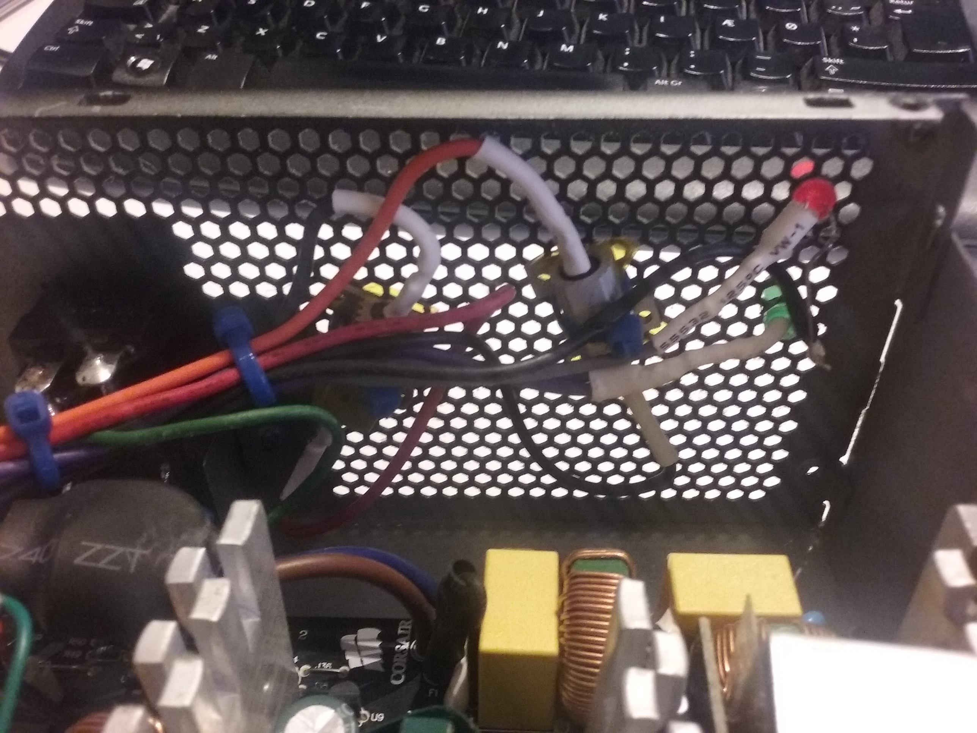

Summary
Colour | Function
Black | GND
Yellow | +12V
Red | 5V dummy load
Orange | 3.3V dummy load / 3.3V sense
Green | PSU ON
Red | 5V - unused
Orange | 3.3V - unused
Blue | -12V - unused
Purple | 5V standby - unused
Grey | Power good - unused

Assembly
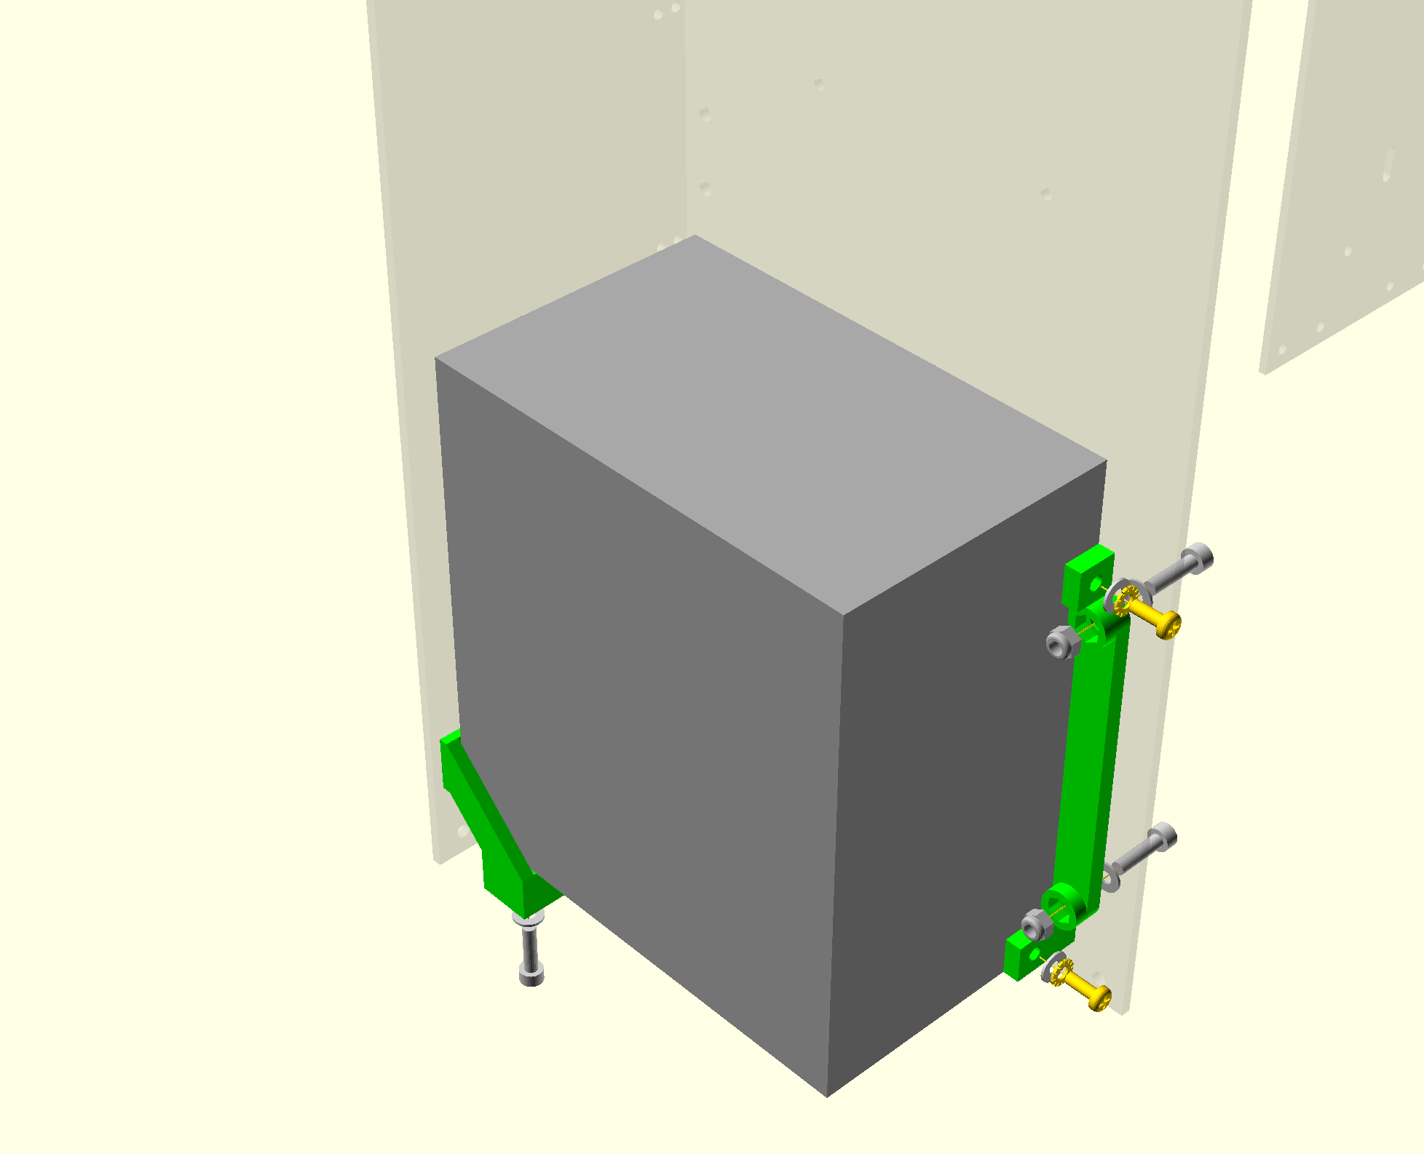
- Put four M4 nyloc nuts in the nut traps of the two brackets.
- Screw the brackets to the frame with M4 x 16mm cap screws and washers.
- Run the wires from the right Z motor, the Y motor and the bed up the corner between the gantry and the right stay before fitting the PSU between the brackets.
- Secure the PSU with two 6-32 x 9.5mm pan screws, M4 star washers and M4 plain washers.

